Virginia Renewable Energy Alliance
2016 Development Report

Leading Renewable Energy Development in the Commonwealth

January 2017

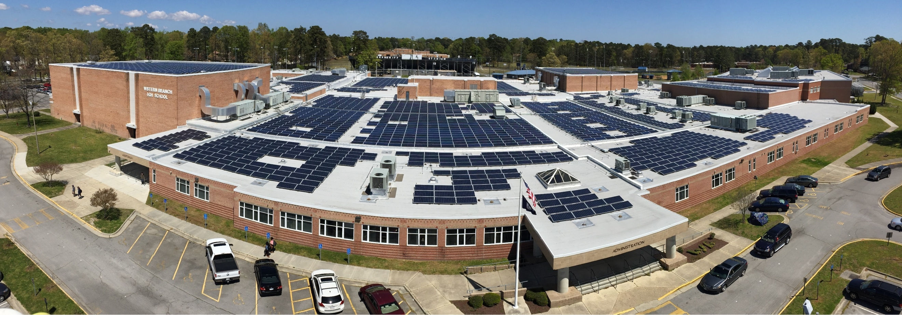
Figure 1: Dominion Virginia Power 1MW Solar Array on Western Branch High School

Table of Contents:

Virginia Renewable Energy Alliance
2016 Development Report

Leading Renewable Energy Development in the Commonwealth

January 2017

Mission Statement…………………………………………………………………………………… 3
2016 Development Summary…………………………………………………………………… 3
Organizational Growth…………………………………………………………………………….. 4
Solar Energy Development………………………………………………………………………. 4
Wind Energy Development………………………………………………………………………. 5
Looking Ahead to 2017…………………………………………………………………………..… 6

Mission

VA-REA leverages the diverse interest and market knowledge of our members, to find solutions that:
- Identify and close the gaps to renewable energy development through collaboration on target initiatives;
- Research and support best industry practices;
- Serve as an authority and resource through public education;
- Foster coordination and partnerships through networking opportunities; and
- Generate policy analysis

2016 Virginia renewable energy recap: VA-REA Members lead the way in development

The year 2016 saw sustained growth for the Virginia Renewable Energy Alliance (VA-REA), as the organization continued to build on its leadership in leveraging the diverse interests of our members to advance Virginia’s renewable energy economy through industry partnerships, networking and public educational events. The renewable energy market in Virginia grew exponentially in 2016, as VA-REA members installed 113 MW of new solar capacity, with another 280 MW of solar energy in the development pipeline for 2017. Our members also project development of 157 MW of in-state wind capacity in 2017 and beyond.

Our Board of Directors grew by 50%, for a total of twelve voting board members. Board members include Sarah Cosby of Dominion (Secretary), Eric Heintz of M&T Bank, Kellen Ingalls of EDP Renewables, Ron Jefferson of Appalachian Power Company, Jonathan Miles of James Madison University, Dylan Reed of Advanced Energy Economy, Cliona Robb of Christian and Barton (Treasurer), Tony Smith of Secure Futures LLC, Tyson Utt of Apex Clean Energy (Chairman), Andrew Vehorn of Old Dominion Electric Cooperative, and Kyle West of Coronal Development. In 2016, the board of directors also appointed Jesse Reist of Secure Futures LLC to serve as its Executive Director.

Best,

Tyson Utt
Chairman of the Board
Virginia Renewable Energy Alliance

Organizational Growth

VA-REA grew significantly in numerous capacities in 2016:
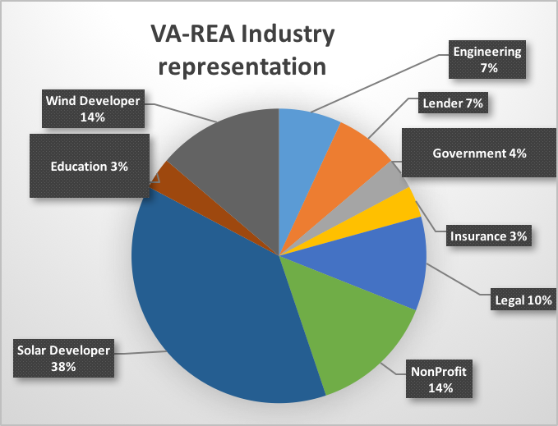
- Membership increased by 300% from 9 to 28
- Board membership increased by 50% from 8 to 12
- Operating budget increased by 100%
- Development and execution of innovative and educational Leadership in Energy Advancement and Development (LEAD) series, with more planned for 2017
- Launched organization social media presence on Facebook and Twitter to educate the public about the mission of VA-REA and our member projects

Solar Energy Development

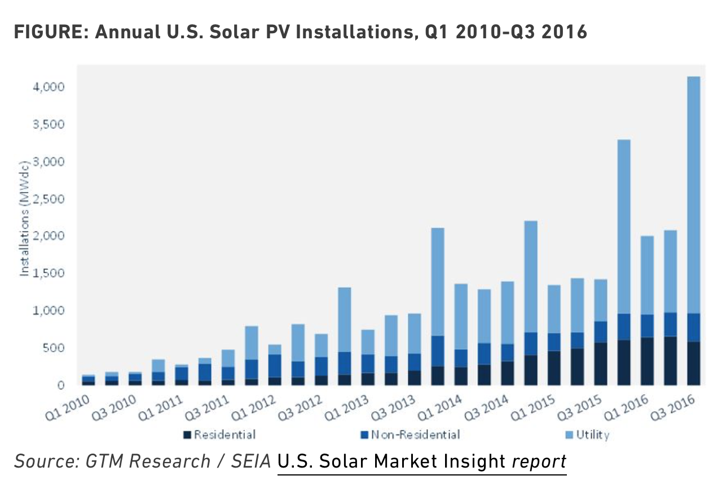
Virginia witnessed an unprecedented year of growth for solar energy in 2016, across the spectrum, at the residential, commercial and utility scales. Record setting growth in all sectors of the solar industry combined with a full development pipeline continued to spur innovation and growth in the solar marketplace, putting the renewable energy source on course to compete with fossil fuels. The unprecedented growth in utility scale development in 2016 was also precipitated under the assumption of a 2016 expiration of the federal ITC.

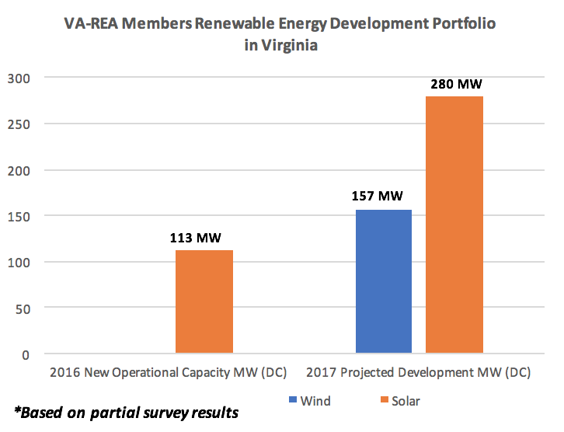
VA-REA members continue to capitalize on the newly emerging renewable energy market in Virginia. Out of the 174 MW (DC) of solar energy currently installed in Virginia, 113 of those Megawatts (DC) were installed in 2016 by VA-REA members. Over 90% of the Virginia growth in newly installed solar capacity in 2016 by VA-REA members came from utility scale development, in keeping with national trends. VA-REA members also contributed more than 9 MW of residential and commercial scale solar development in 2016. The solar growth trend in Virginia will continue in 2017, with another 280 MW of new solar capacity projected by VA REA members.

The Virginia Solar Energy Development Authority maintains a complete list of solar installations in Virginia that can be found on the Virginia DMME website.

Wind Energy Development

Wind energy developers are moving forward with several projects throughout the Commonwealth. VA-REA members Apex Clean Energy and EDP Renewables are developing 75MW and 70MW wind facilities in South-West Virginia, respectively. Elsewhere in the Commonwealth, Dominion Virginia power continues to examine the feasibility of a 12 MW offshore wind farm. VA-REA members project the development of 157 MW of wind development in Virginia in 2017.

In 2016, VA-REA partnered with James Madison University to increase access to wind research and development in the Commonwealth, with the goal of incorporating JMU’s Virginia Center for Wind Energy into VA-REA’s educational mission.

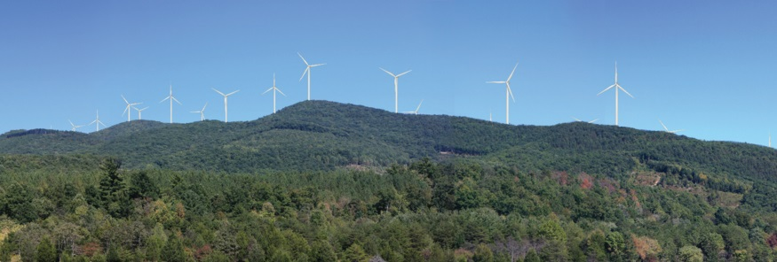
Figure 2: Artist rendering of Apex Clean Energy's Rocky Forge Wind farm in Botetourt County

Looking Ahead to 2017

VA-REA anticipates a robust year in 2017, building on its innovative capacity and leadership roles to foster industry partnerships, and provide networking and public educational events. As the central piece of our strategic outreach plan, we have planned a series of Leadership in Energy Advancement and Development (LEAD) workshops for 2017:

- Addressing Virginia’s Energy Gap with Renewables
  - Roanoke College: February 28th 2017
- Performance Based Ratemaking. A New Business Model for Virginia Utilities?
  - University of Richmond: April 5th 2017
- Renewable Energy In Higher Education
  - Location TBD: September 2017
- 2017 Annual Networking Event and Members Meeting
  - Richmond, December 2017

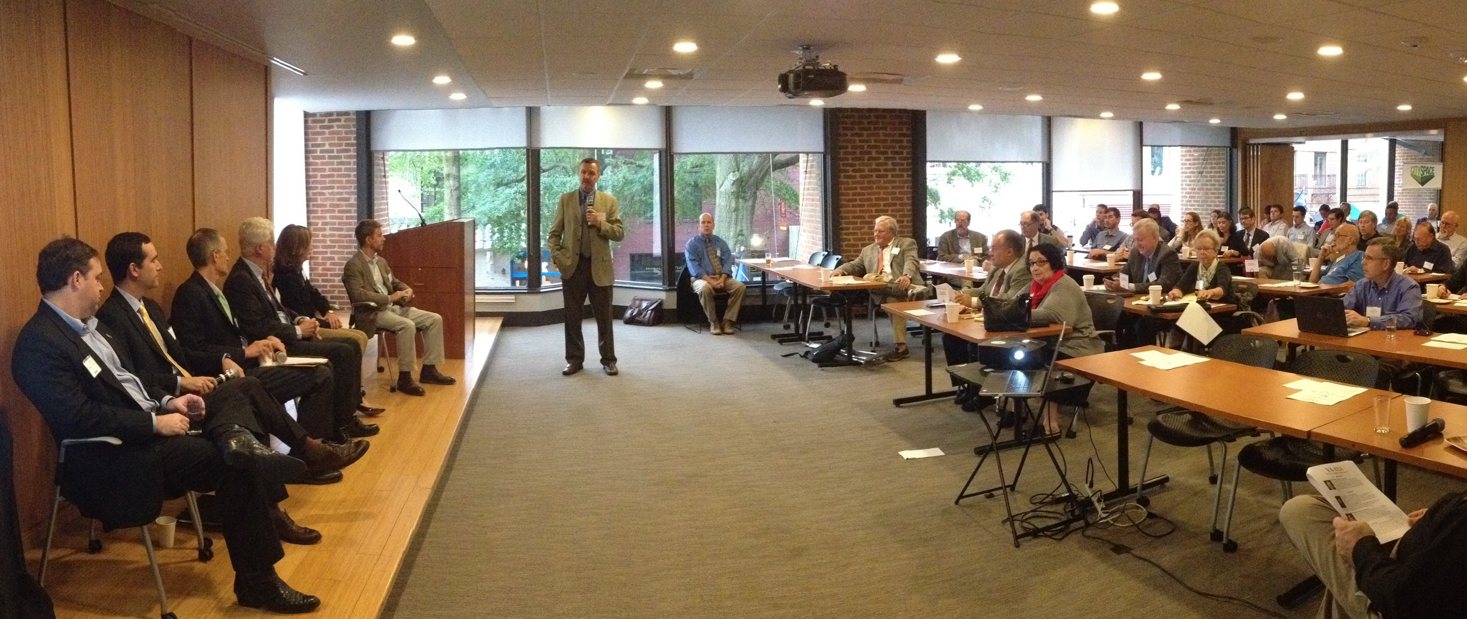
Figure 3: Panelists interact with the audience at VA-REA's 2016 LEAD series event - Barriers and Opportunities in Virginia's Renewable Energy Market

Virginia Renewable Energy Alliance
909 E. Main Street
Suite 1200
Richmond, Virginia 23219

@VARenEnergy
Virginia Renewable Energy Alliance

Based on partial survey results from VA-REA and DMME statistics as of 12-12-16

